Accreditation
The University of Georgia is accredited by the Commission on Colleges of the Southern Association of Colleges and Schools (SACSCOC) www.sacscoc.org to award baccalaureate, masters, specialist and doctorate degrees. Contact the Commission on Colleges at 1866 Southern Lane, Decatur, Georgia 30033-4097 or call (404) 679-4500 for questions about the accreditation of the University of Georgia.
The professional PhamD program and the Continuing Pharmacy Education (CPE) programs in the University of Georgia’s College of Pharmacy are accredited by the Accreditation Council for Pharmacy Education (ACPE) www.acpe-accredit.org. The Council can be contacted at 135 S. LaSalle Street, Suite 4100, Chicago, Illinois 60603-4810 or by calling (312) 664-3575.
The Residency Programs in the University of Georgia’s College of Pharmacy are accredited by the American Society of Health-System Pharmacists (ASHP) www.ashp.org. The association can be contacted at 7272 Wisconsin Avenue, Bethesda, MD 20814 or by phone at (301) 664-8656.

Graduation Rates for the PharmD
The UGA College of Pharmacy monitors the attrition of students and the rate at which our students complete their program on-time (within 9 semesters). A variety of personal and academic issues impact on-time graduation rates and overall graduation rates. The College of Pharmacy evaluates these situations to assist students with their academic and professional goals if possible. The following table shows our most recent graduation rates.
Graduating Class | # of Students Entering the Program | 2022# of Students Who Left Program | % of Students Who Left Program | # of Students Dismissed | # of Students Not Graduating on Time (4 years) | % of Students Not Graduating on Time (4 Years) | Reason for Not Graduating on Time
2020 | 142 | 3 | 2.11% | 4 | 7 | 4.93% | Personal, Academic
2021 | 138 | 4 | 2.8% | 4 | 8 | 5.7% | Personal, Academic
2022 | 139 | 6 | 4.3% | 2 | 14 | 10% | Personal, Academic
2023 | 133 | 3 | 2.26% | 2 | 1.5% | 5.26% | Personal, Academic
2024 | 141 | 8 | 5.67% | 2 | 14 | 9.93% | Personal, Academic

NAPLEX Performance
To gain state licensure to practice pharmacy, graduates of the PharmD program must pass the North American Pharmacist Licensure Examination (NAPLEX) offered by the National Association of Boards of Pharmacy (NABP). The Accreditation Council for Pharmacy Education (ACPE) compiles statistics on the performance of all candidates who take the exam. The table below shows the NAPLEX pass rate of UGA graduates taking the test for the first time in comparison to the National average pass rate for graduates taking the test for the first time. The pass rate for UGA PharmD graduates is consistently higher than the national average. Please note that the National Board of Pharmacy changed the blueprint for the NAPLEX exam for the Class of 2022 leading to drop-off in pass rates nationally.

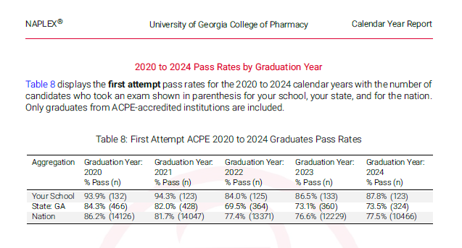

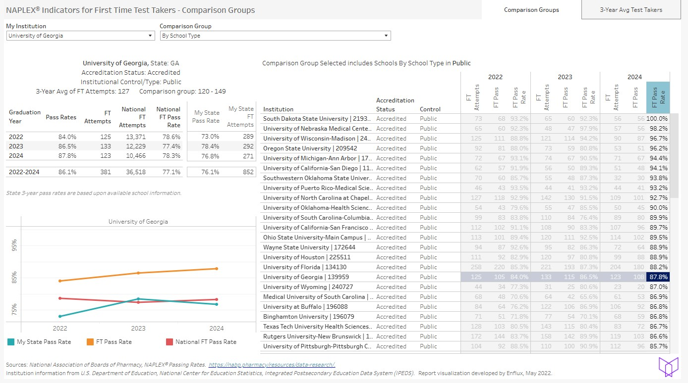
This table shows trend data related to our NAPLEX performance and in comparison to other Colleges of Pharmacy. The Class of 2024 had the 17th highest 1st time pass rate on the NAPLEX for all Colleges/Schools of Pharmacy accredited by ACPE. We had the 5th highest pass rate among large programs (100+ graduates). The HIGHEST pass rate in Georgia. The 4th highest pass rate in the Southeastern region of the US.
MPJE Performance
To gain state licensure to practice pharmacy, graduates of the PharmD program must pass the Multistate Pharmacy Jurisprudence Examination® (MPJE®) offered by the National Association of Boards of Pharmacy (NABP). The Accreditation Council for Pharmacy Education (ACPE) compiles statistics on the performance of all exam candidates. The table below shows the results for students who graduated and subsequently tested between the 2020 and 2024 calendar years as compared to graduates from Georgia and all ACPE-accredited institutions. Students who take the MPJE take different forms of the exam based on the states and jurisdictions where they wish to gain licensure. The table below shares these comparisons of how our students perform. For example below, “Your School” refers to UGA College of Pharmacy and how our students overall performed on the MPJE regardless of the jurisdiction. The In-state refers to how our students performed on the MPJE for the State of Georgia only. The Out-of-State rate refers to only those exams taken outside the State of Georgia.
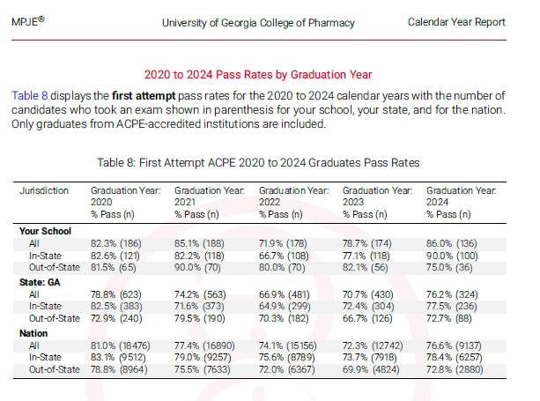
Assessment of Student Learning
The College of Pharmacy uses quantitative and qualitative approaches to assess student learning in the PharmD program. The following are highlights of data related to our graduating students as shared on the American Association of Colleges of Pharmacy Graduating Student Survey for the Class of 2023. This includes benchmark comparisons to our Peer group in the Southeastern Conference and the State of Georgia.

